Web Authoring 5N1910

Sean Rattigan

2021

Table of Contents

Introduction 2

Feasibility & Requirements Analysis 2

System Design 3

Page planning 3

Sitemap 3

Layout 3

Hosting 3

Design Implementation 5

Home page 5

Reuse Page 6

Recycle page 7

Contact Page 8

Bonus Features 9

Favicon 9

404 Page 9

XML Sitemap 9

Validation Testing 10

Deployment 13

Post Testing 14

Conclusion 16

# Introduction

## Feasibility & Requirements Analysis

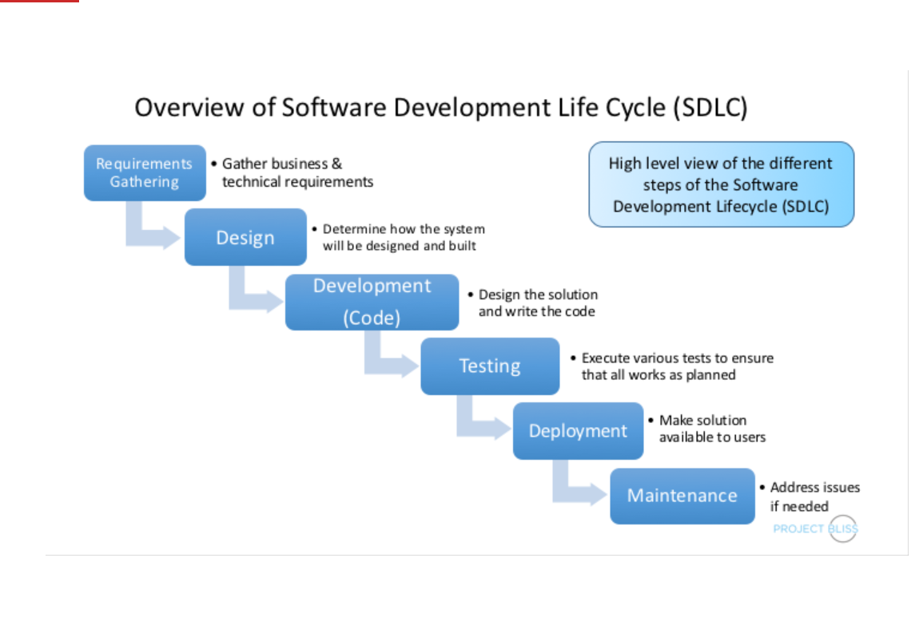

We use SDLC model to develop this site.

The purpose of this site:

* Information about how the smart home.
* How can we save electricity and time.
* The life would be faster and we will have more control

Who would be interested in this site. Everybody, but not including kids, companies, factories, super markets.

It can save some electricity by using solar power for the house and It is friendly to the environment

System Design

## Page planning

|  |  |  |
| --- | --- | --- |
| Page | Content | Objects/style |
| all | Meta tags: description, keywords, charset, robots, author  Sections: nav, header, content, footer | Div for blocks  H1, h2,p,img |
| index | About, smart home, life easier, faster and save electricity in some way. | Img, ol, |
| systems | Systems, What type of devices, table, link to the contact form, site links to external sites | Img, table,a |
| maintenance | Maintenance for the devices, video, img, | Img, video, |
| Contact form | Slider and a form | frame |

Sitemap

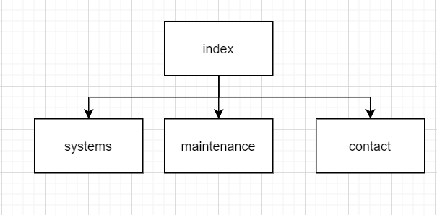

## Layout

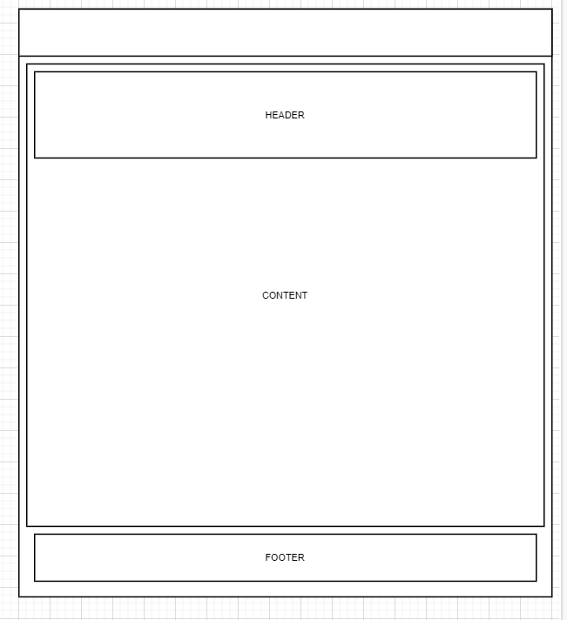

## Hosting

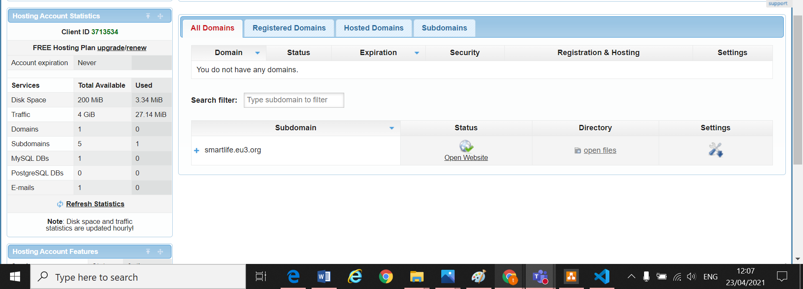 Design Implementation

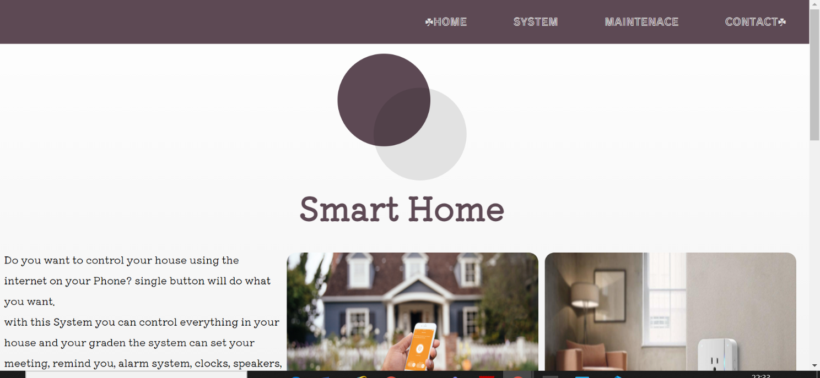

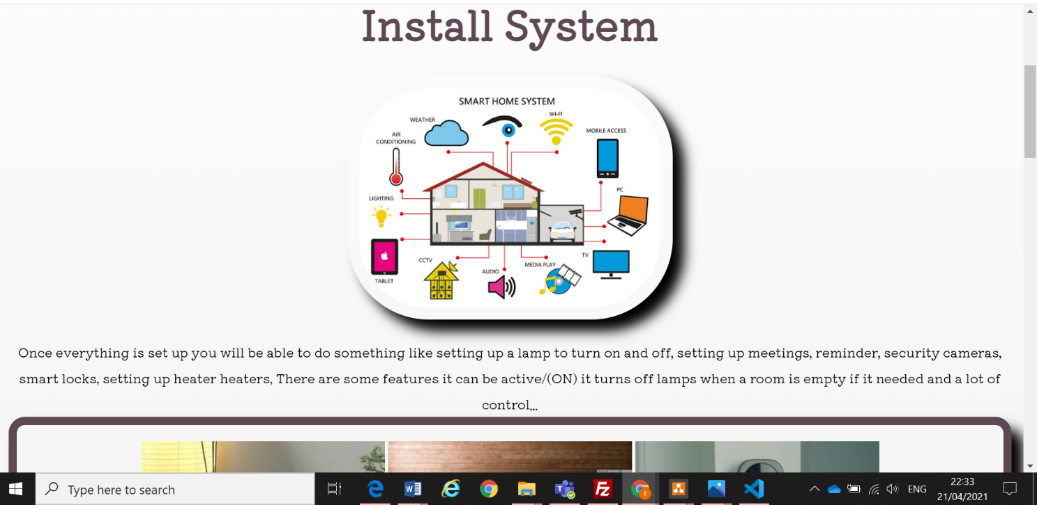

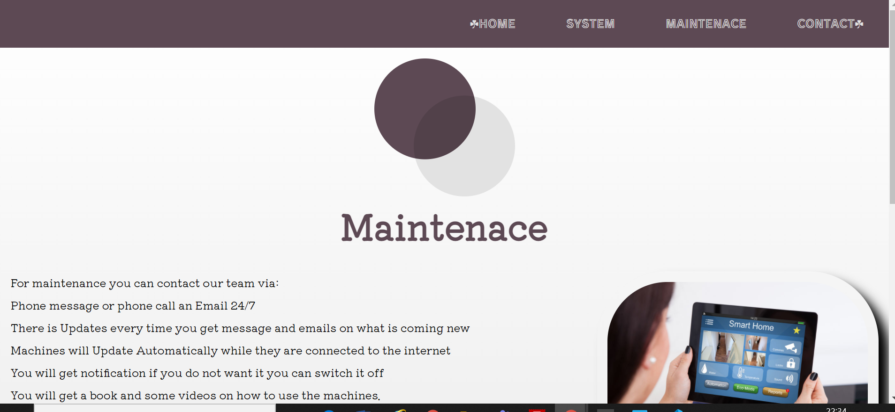

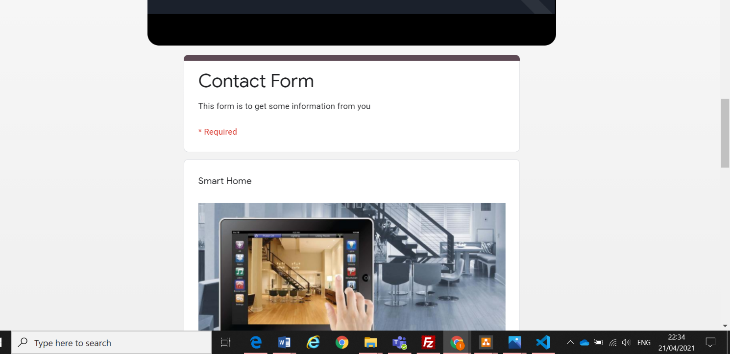Bonus Features

### Favicon

### 404 Page

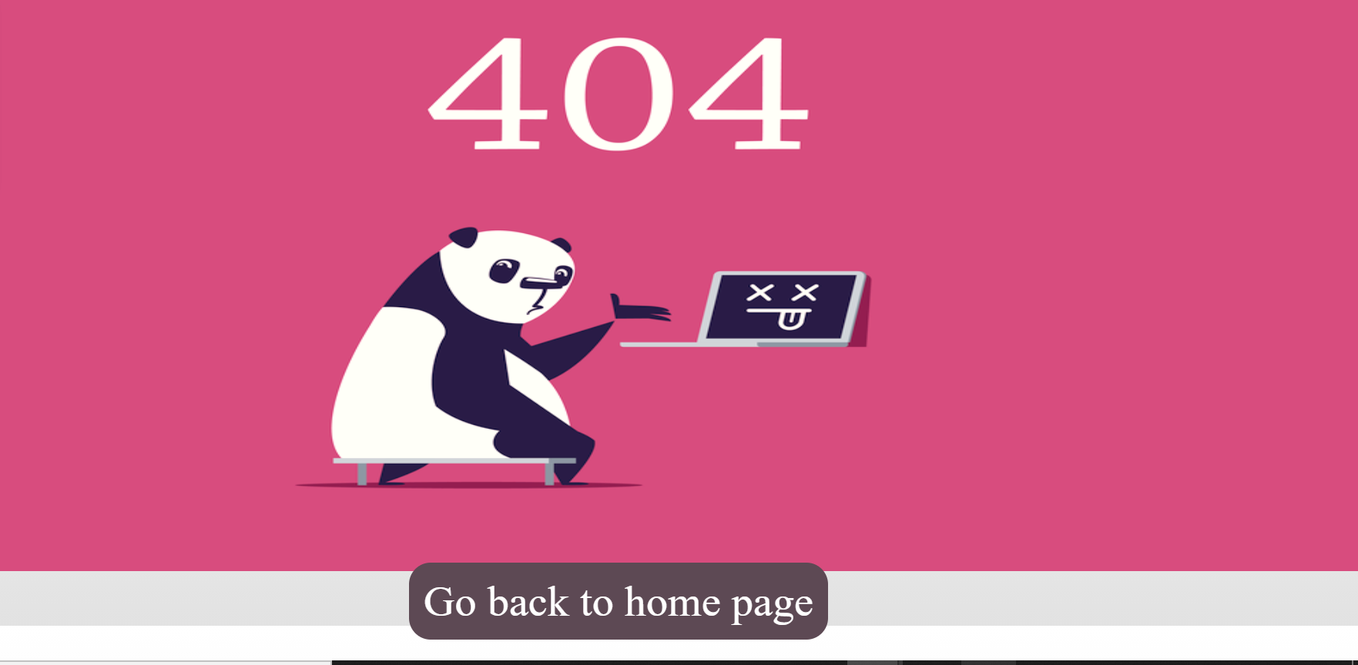

### XML Sitemap

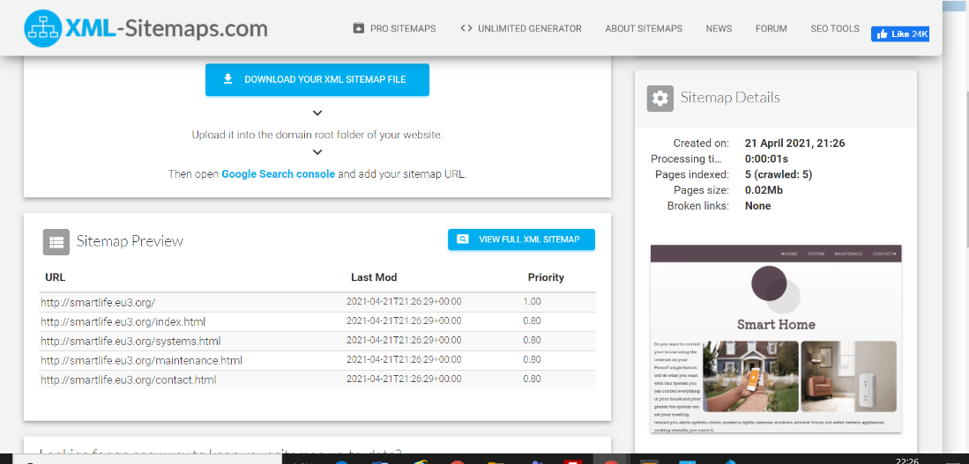

https://www.xml-sitemaps.com/download/smartlife.eu3.org-3d7a8b988/sitemap.xml?view=1

# Validation Testing

All html pages were validated using the W3C validator.

|  |  |
| --- | --- |
|  |  |
|  |  |

The css page was validated on the W3C jigsaw validator

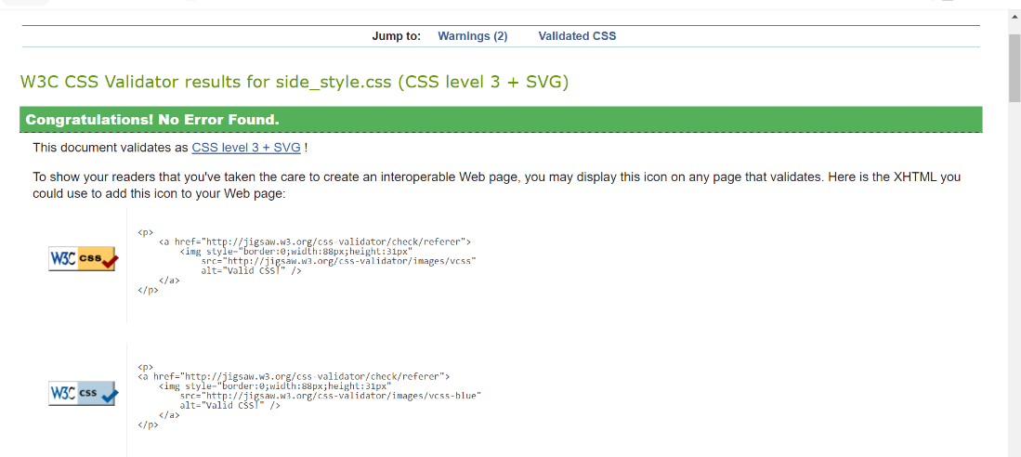

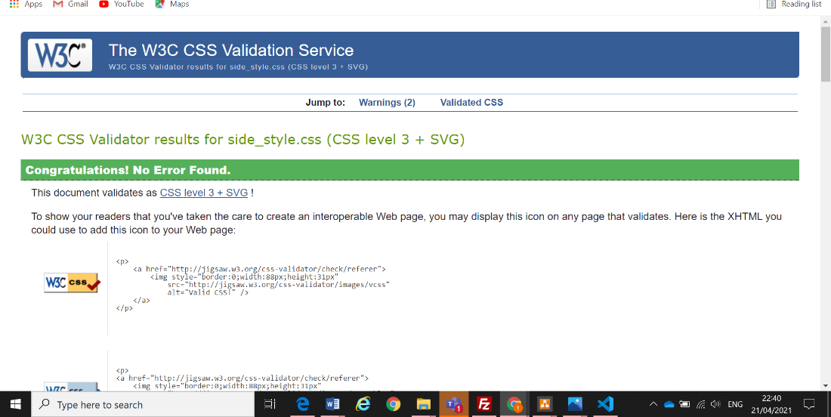

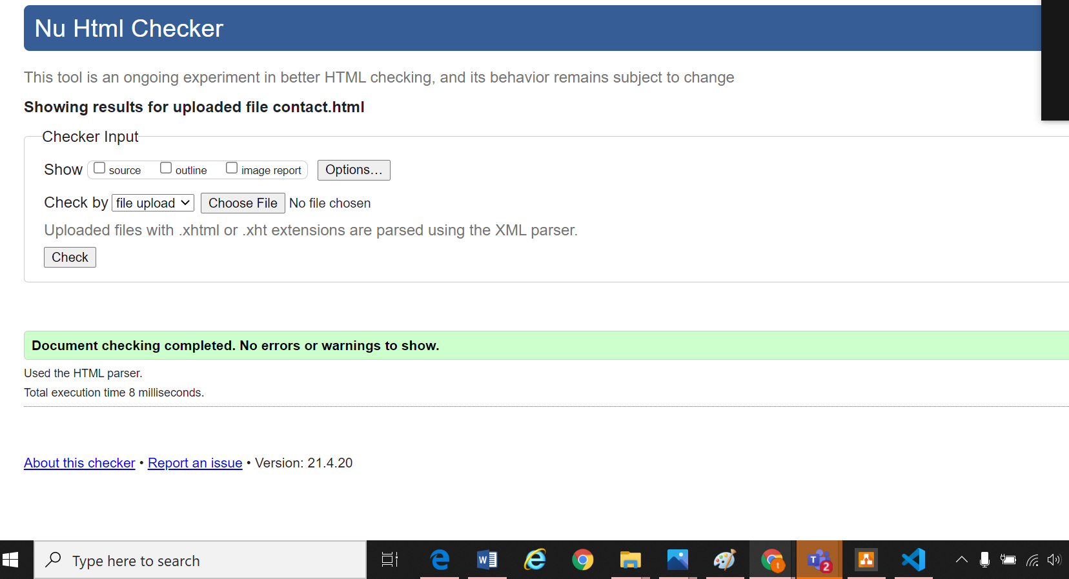

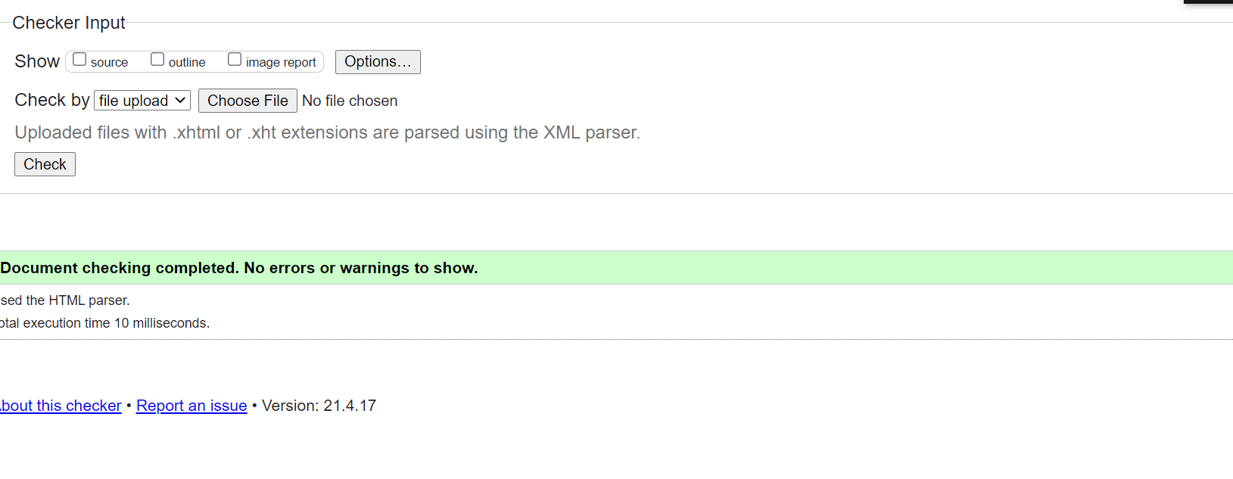

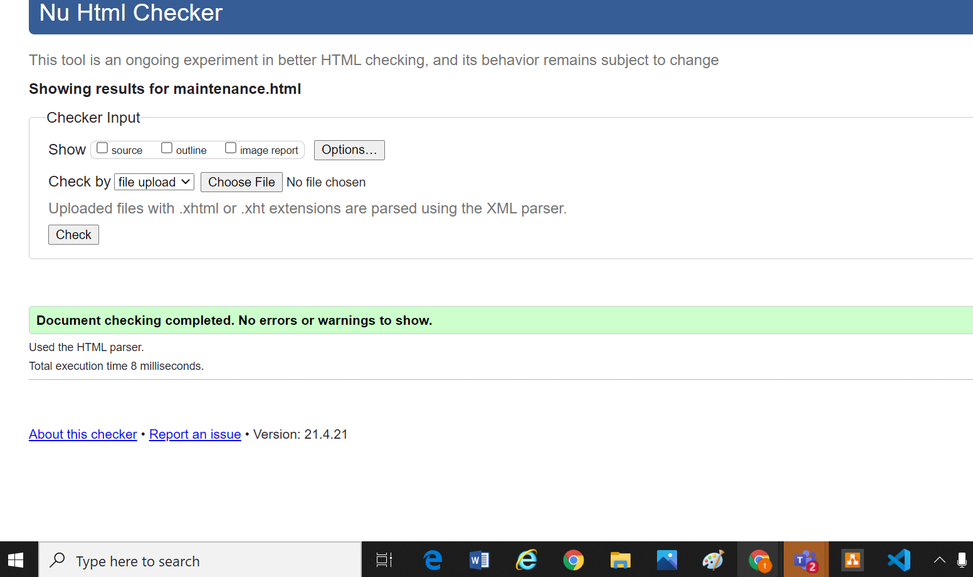

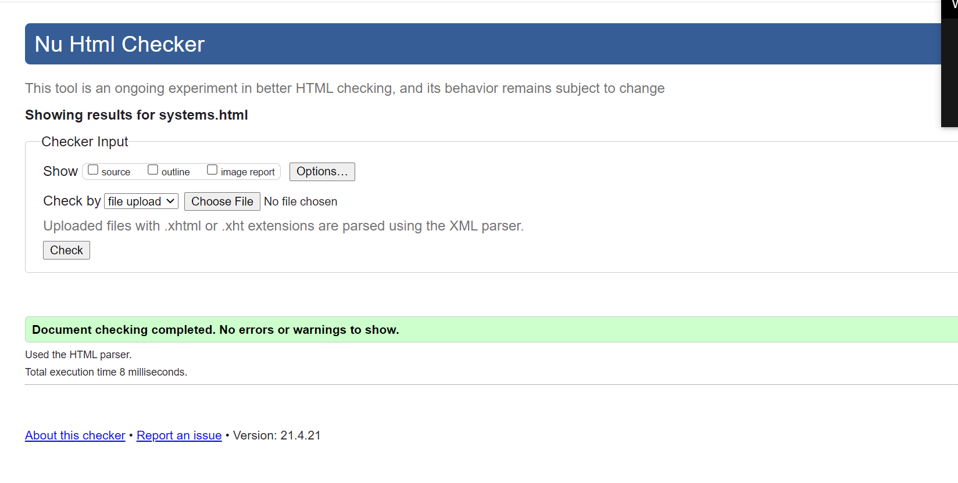

# Deployment

http://smartlife.eu3.org/

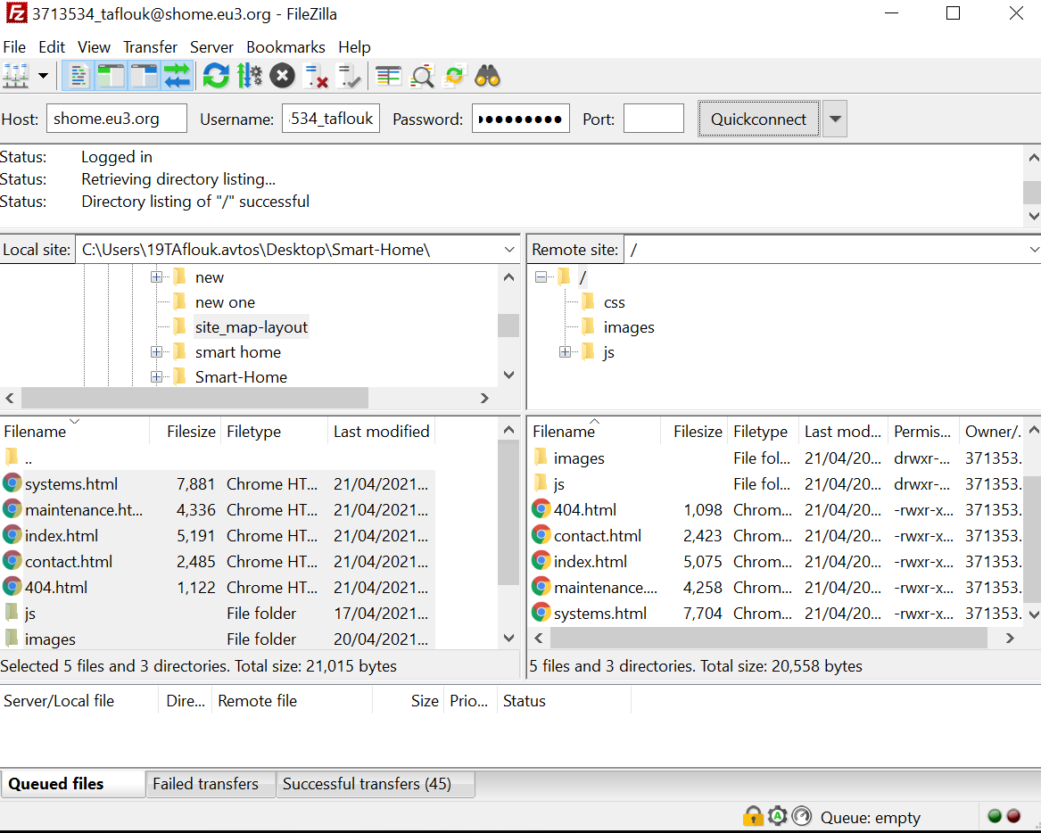

# Post Testing

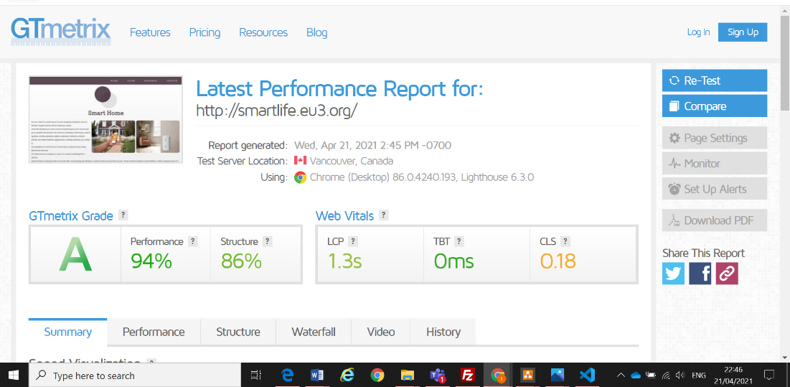

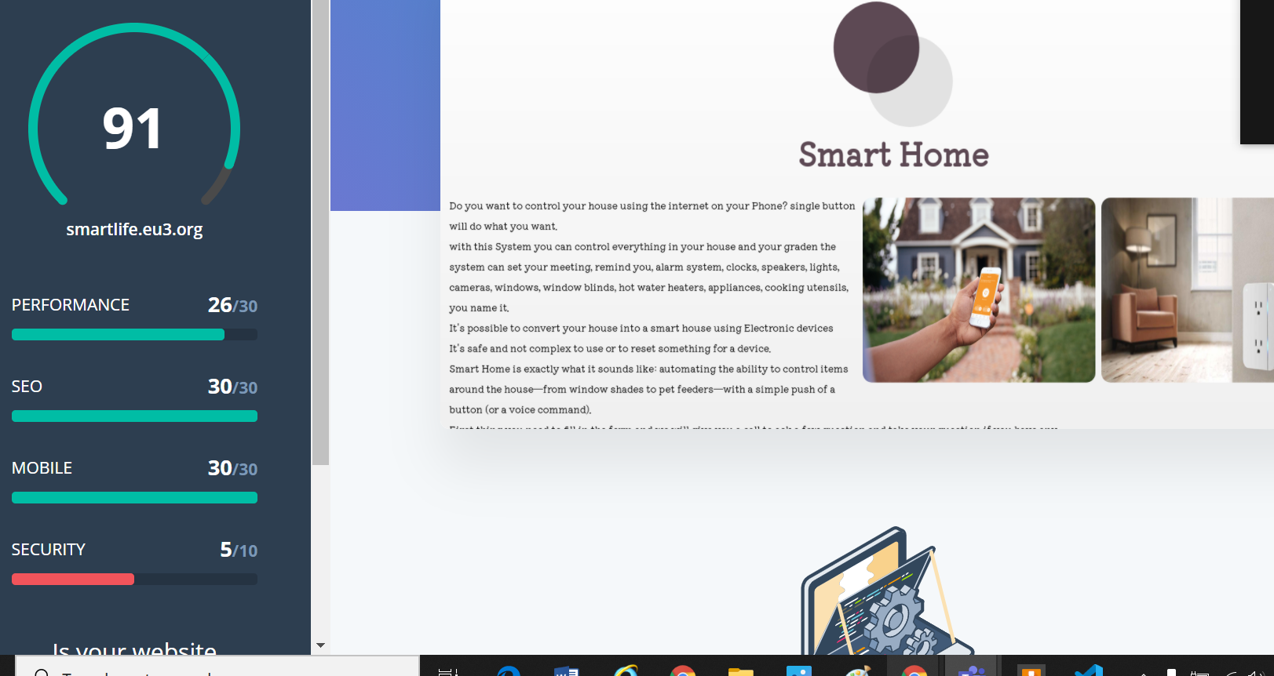

# Conclusion

It was hard to get an idea for the project and it takes time and We have to follow the instructions for the waterfall to get good product in the end step by step.